SOP for adding an new disk on OLVM 4.3
Prepared by: solaianandh A
Kindly update this document whenever an change is needed.

Step 1:- login to the respective OLVM
Step 2:- navigate to computeà virtual machines à search the VM intended for doing the Capacity uplift

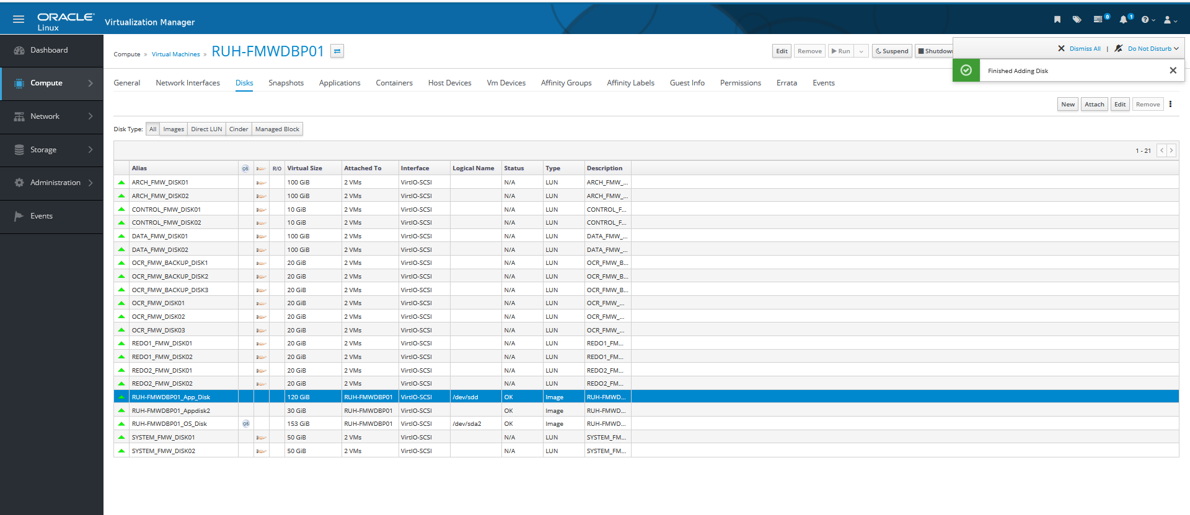
Step 3:- validate the existing the mount point is from which VG, hence we must add the new disk from the same VG. So , this will avoid any domain conflict
Step 4:- here in this case,

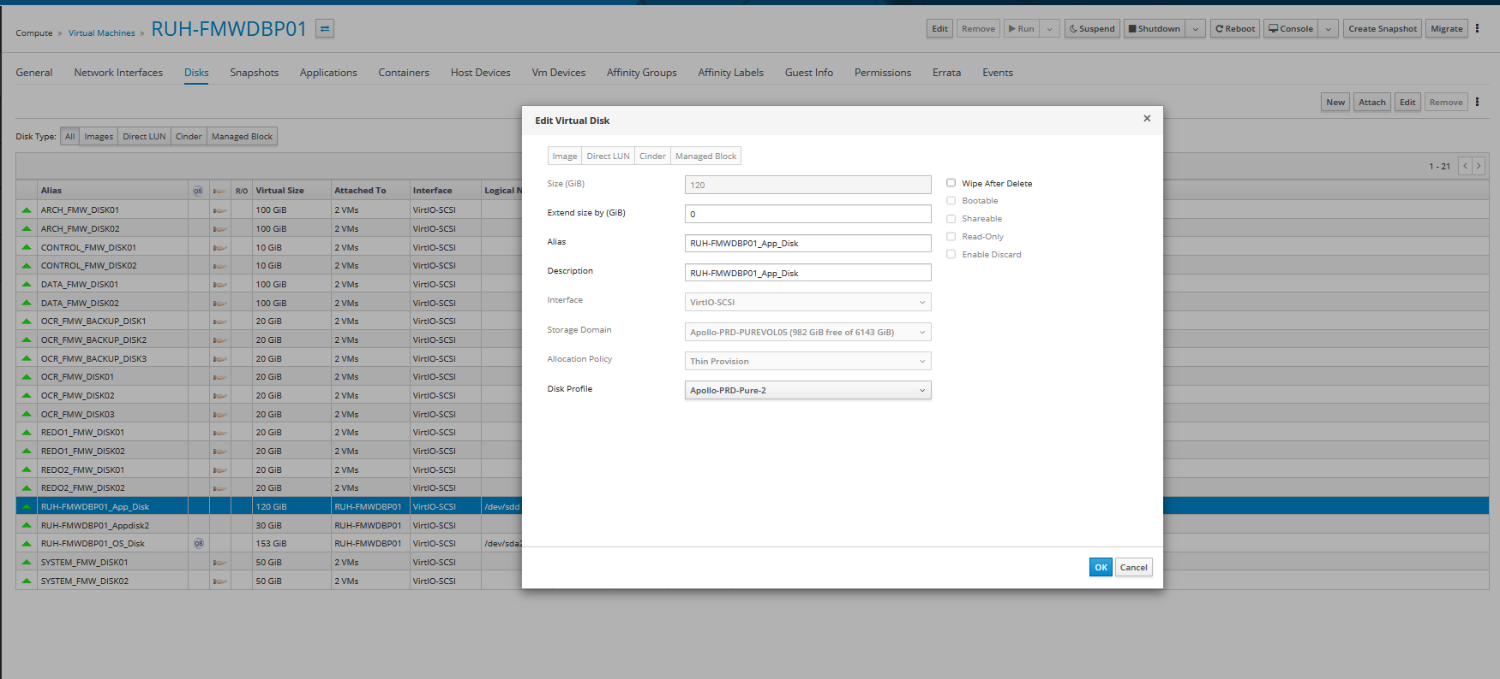
So, we must add an new disk by selecting the new option on the disk section under the respective vm properties and specify the size and give the description and alias that suits the case so in case of vm crash it avoid any issues.

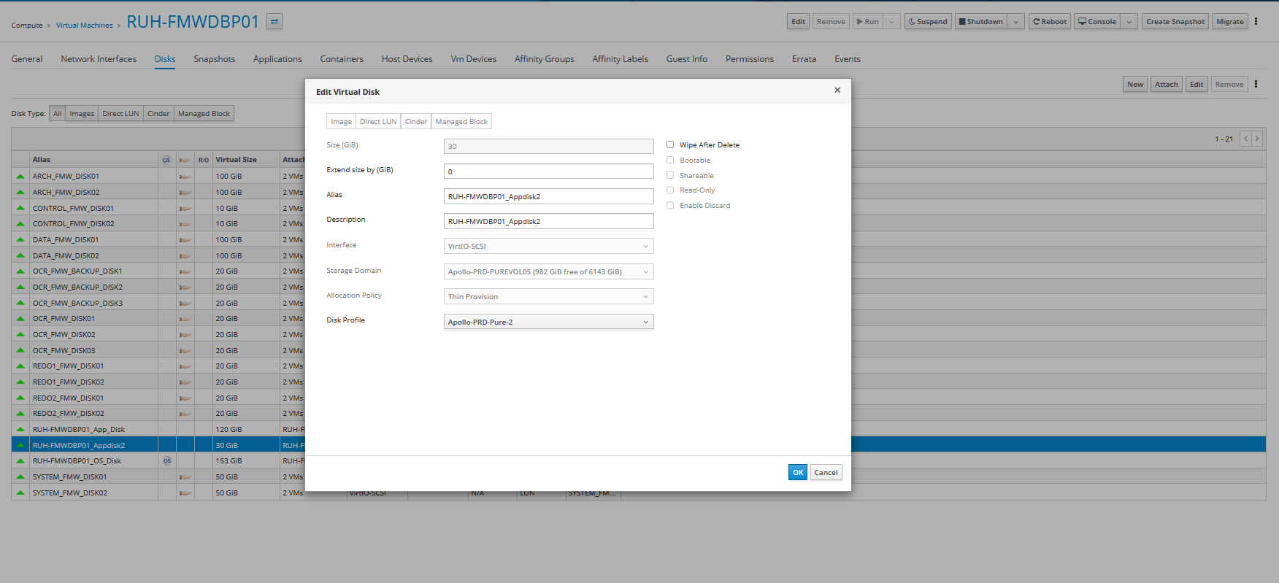
After adding the disk, it will be updating the disk which takes 2 min, you can see the progress sunder events
Then validate on the VM level via lsblk command to confirm the newly added disk exists, usually an new octect after the existing disks count and name. in this case its sdu
Lsblk result before disk addition:-
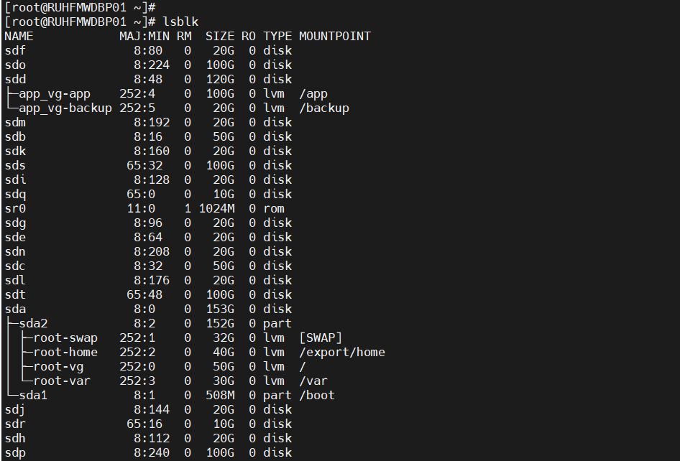
Lsblk result after disk addition:-
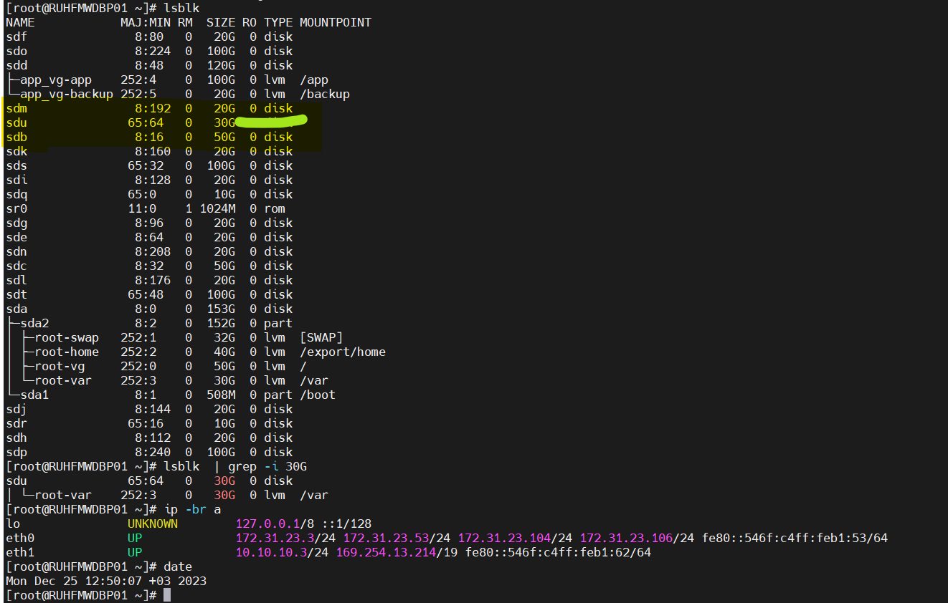

Please extend the intended file systems accordingly,

File system size before expansion:-
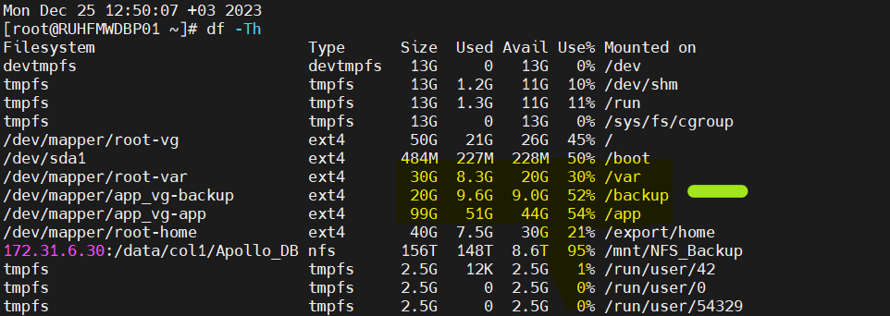
File system size after disk resize :-

